
ASSIGNMENT-1
AIM: Implement NOT, AND OR gates using NAND gates using NAND2TETRIS Simulator SCHEMATIC DIAGRAM, BOOLEAN EXPRESSION AND TRUTH TABLE

Name: Sukhvinder Kaur
Section: D
Roll NO: 2501010272

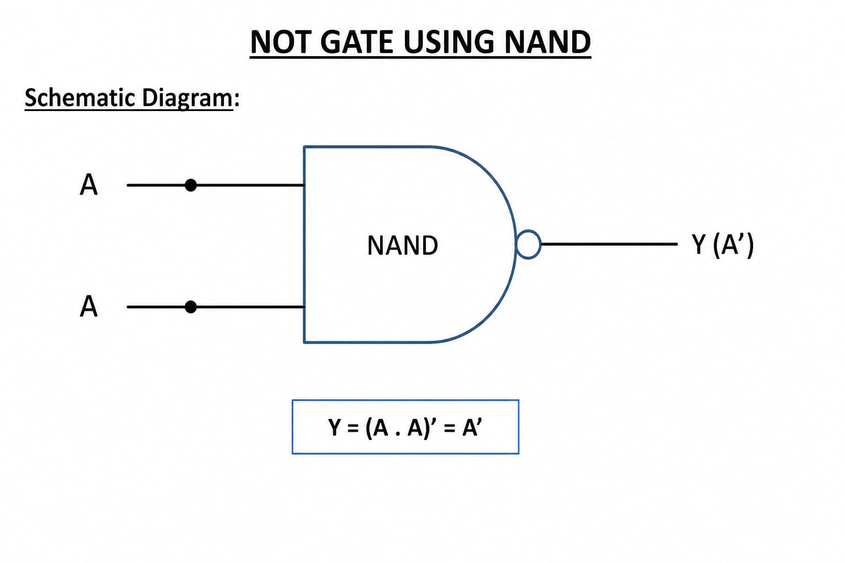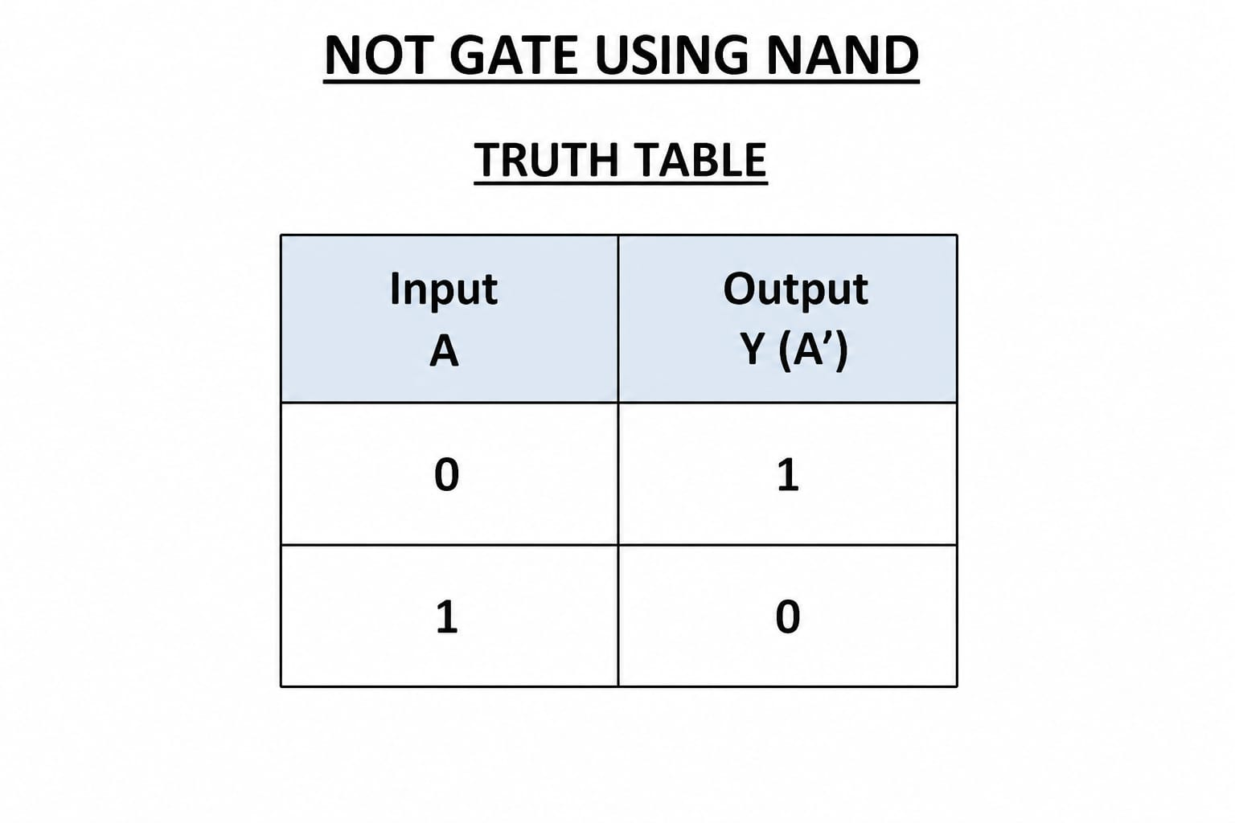
CODE:
CHIP Not {
IN in;
OUT out;

PARTS:
Nand(a=in, b=in, out=out);
}
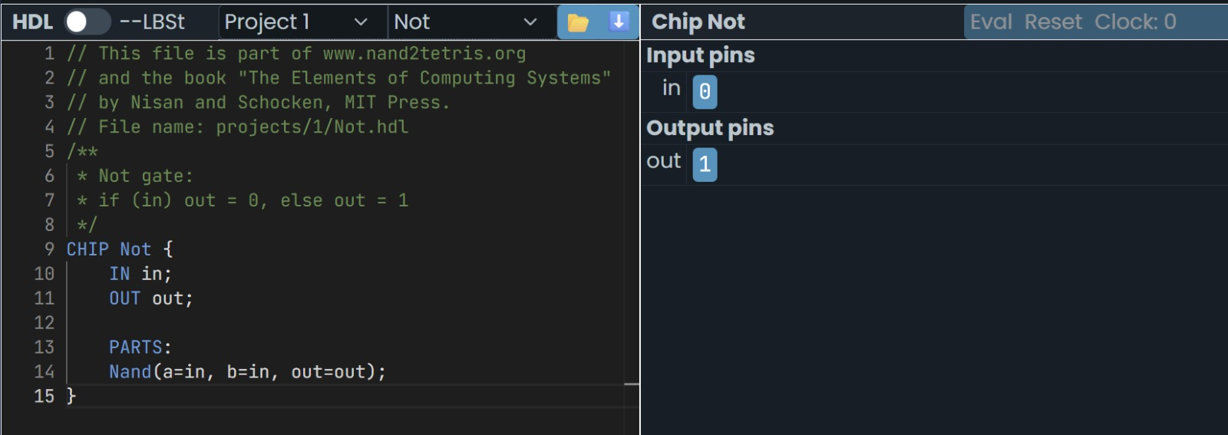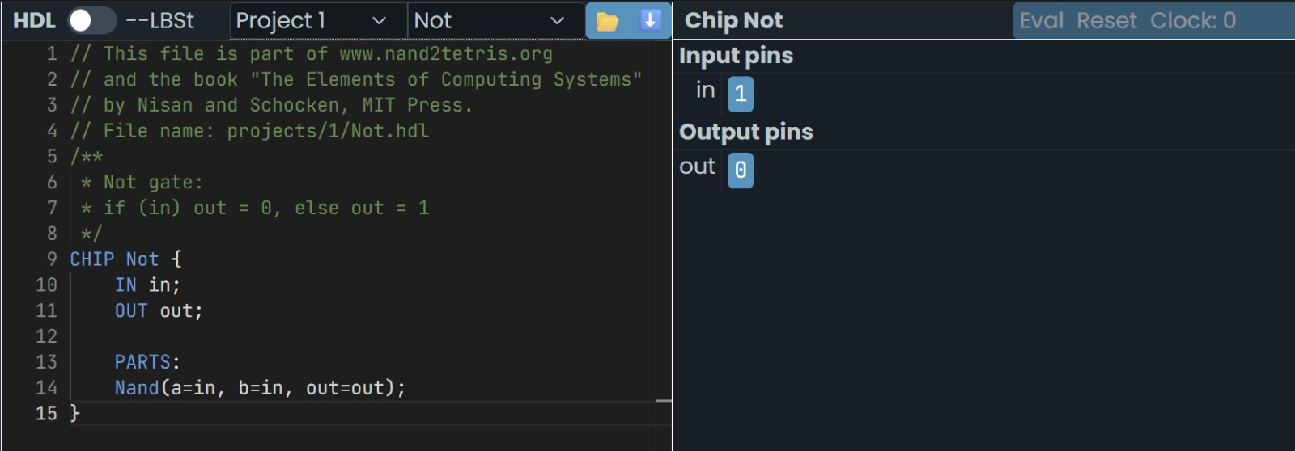
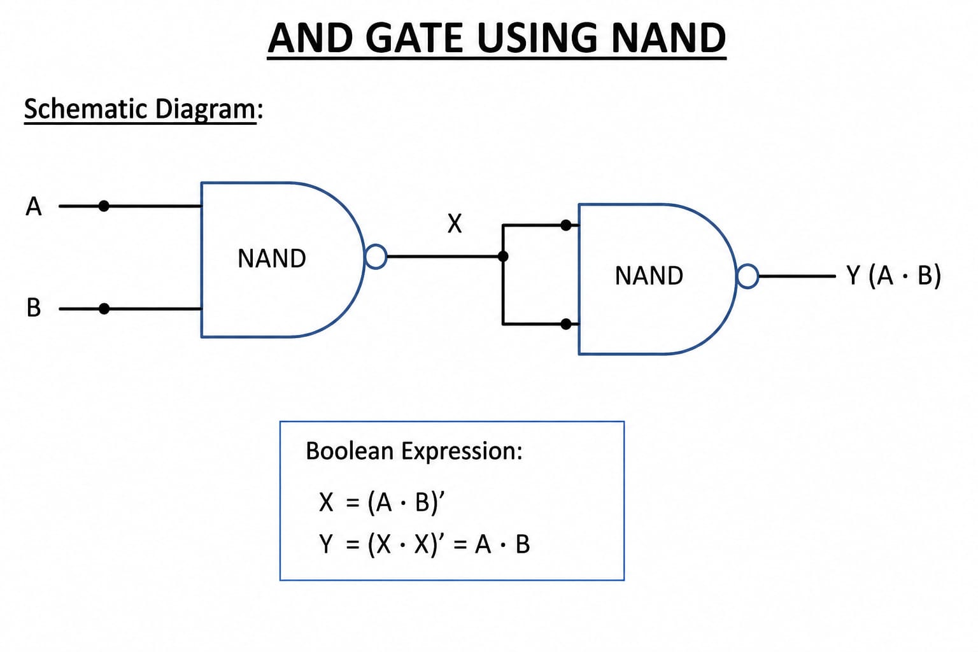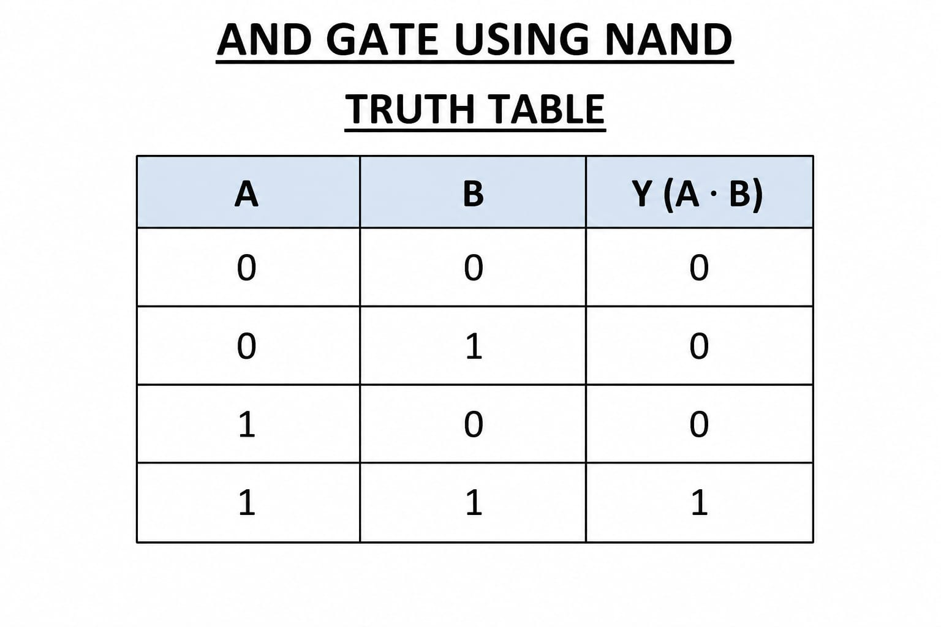
Code:
CHIP And {
IN a, b;
OUT out;

PARTS:
Nand(a=a, b=b, out=temp);
Nand(a=temp, b=temp, out=out);
}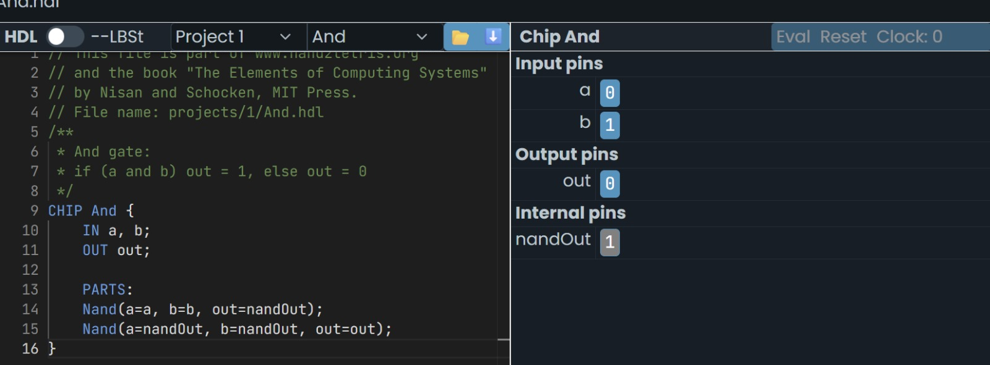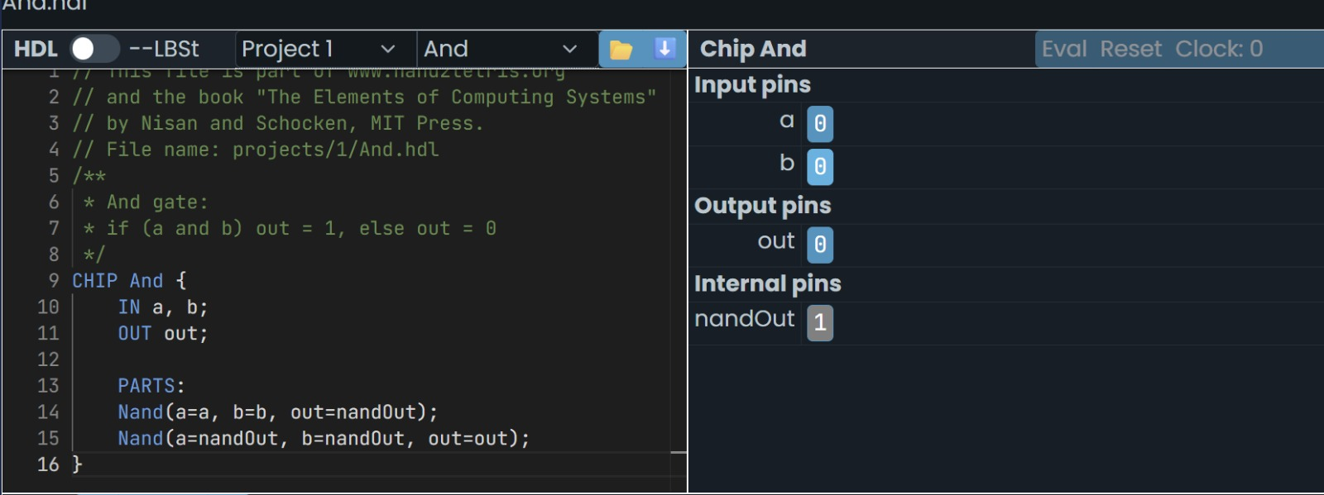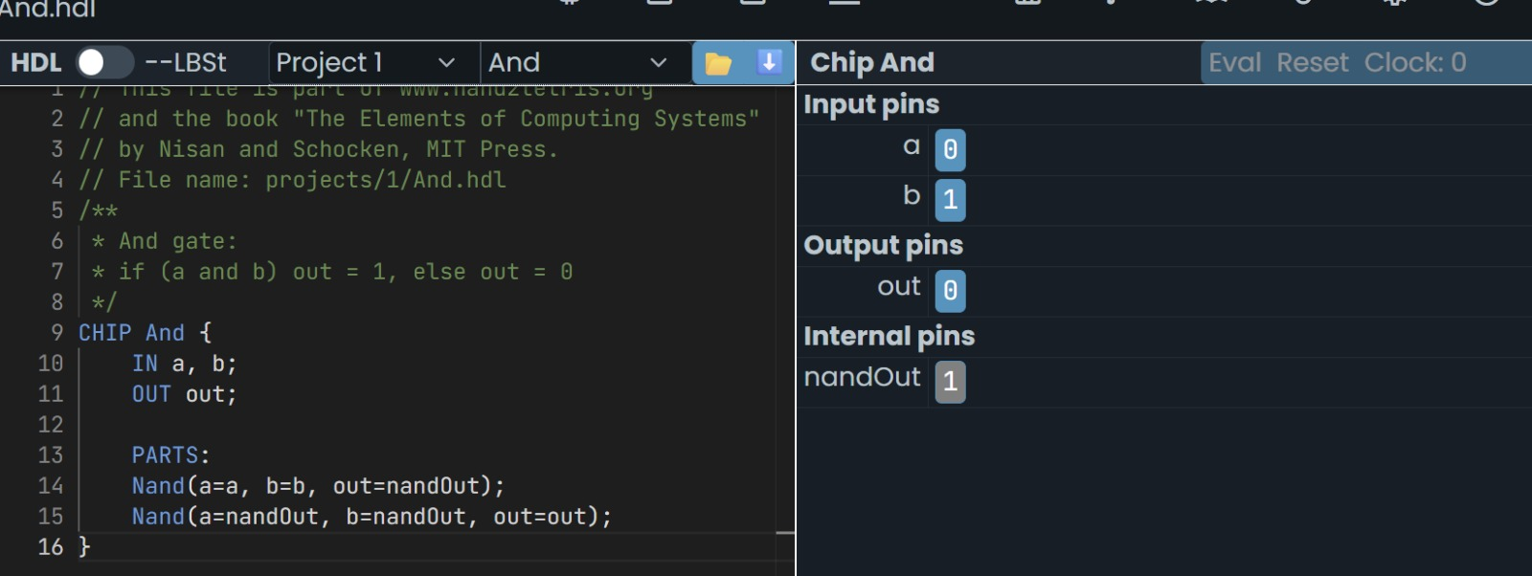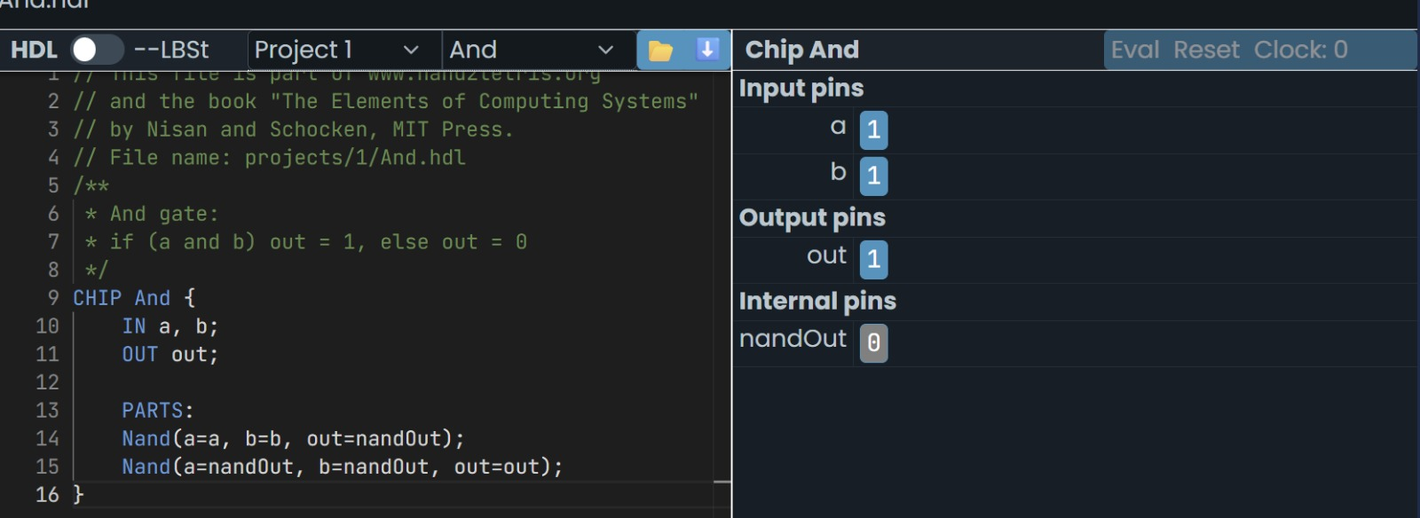

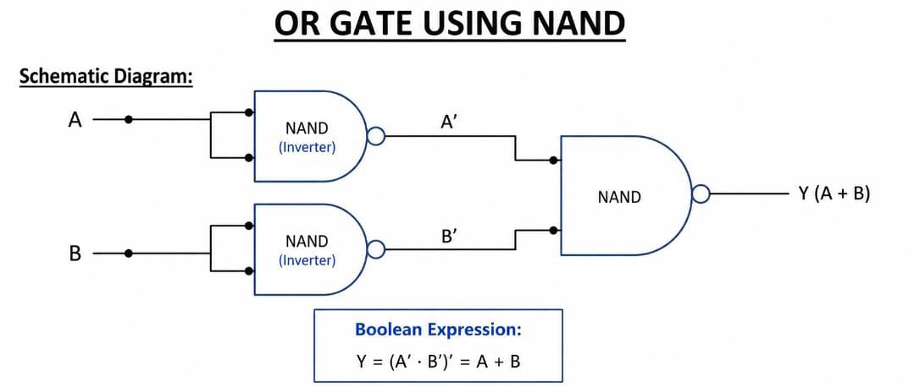

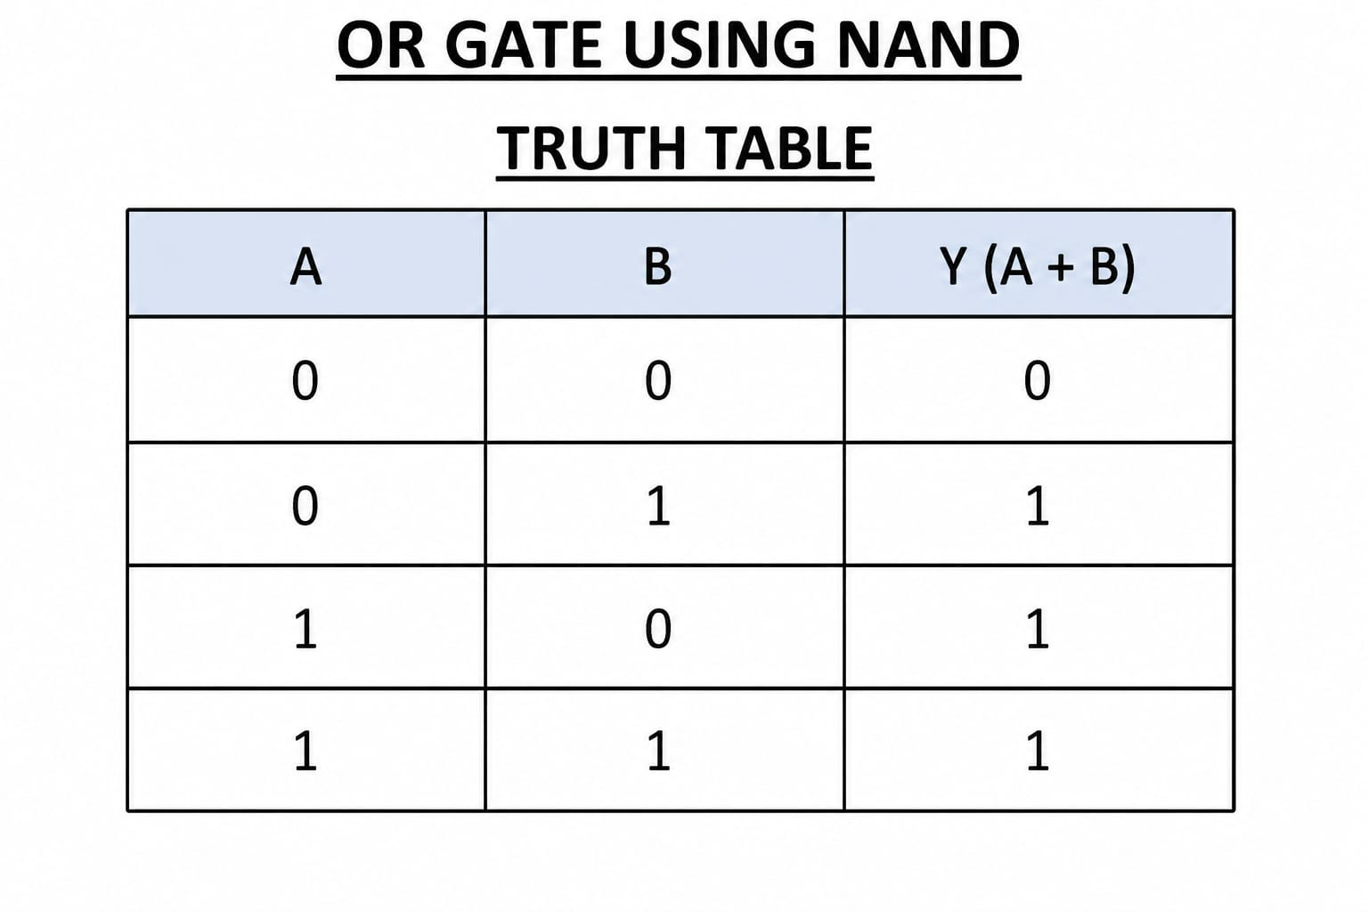
Code:
CHIP Or {
IN a, b;
OUT out;

PARTS:
Nand(a=a, b=a, out=nota);
Nand(a=b, b=b, out=notb);
Nand(a=nota, b=notb, out=out);
}

